MIMD System Architectures:
- Refers to the connection of the processors w.r.t system memory.
- A Symmetric multiprocessor, or SMP, is a computer system that has two or more processors with comparable capabilities (do not have to be identical).
=> All processors must be capable of performing the same functions; this is the symmetry of SMPs.
=> The processors all have access to the same I/O devices and memory modules.

Uniform Memory Access (UMA) architecture
- One type of SMP is the Uniform Memory Access (UMA) architecture.
- UMA gives all CPUs equal(uniform) access to all locations in shared memory.
- They interact with shared memory via some communication mechanism.
- Each processor may have its own cache memory, not directly accessible by the other processors.
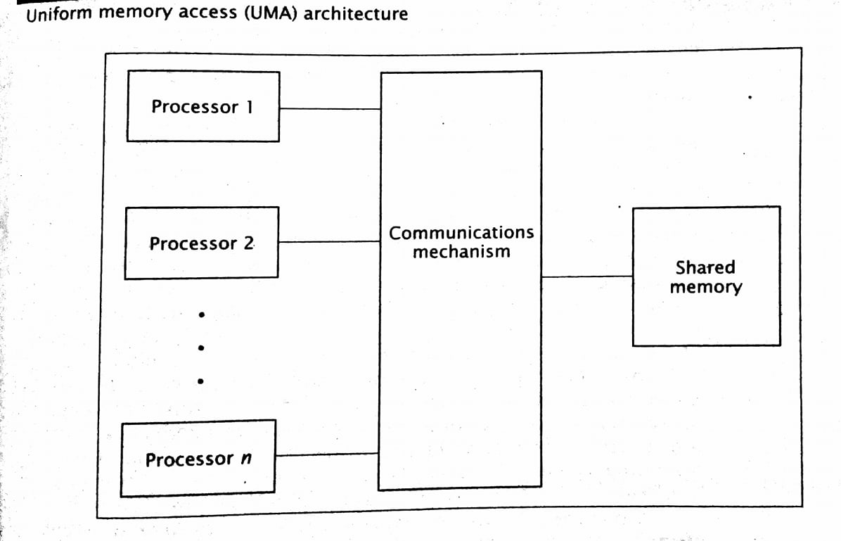

Non - Uniform Memory Access (UMA) architecture

- Non-uniform Memory
Access (NUMA) do not allow uniform access to all shared memory locations.
- The architecture still allows all processors to access all shared memory locations.
- However, each processor can access the memory module closest to it, its local shared memory, more quickly than the other modules; hence, the memory access times are non-uniform.
Unlike UMA machines, NUMA computers may not be SMP.
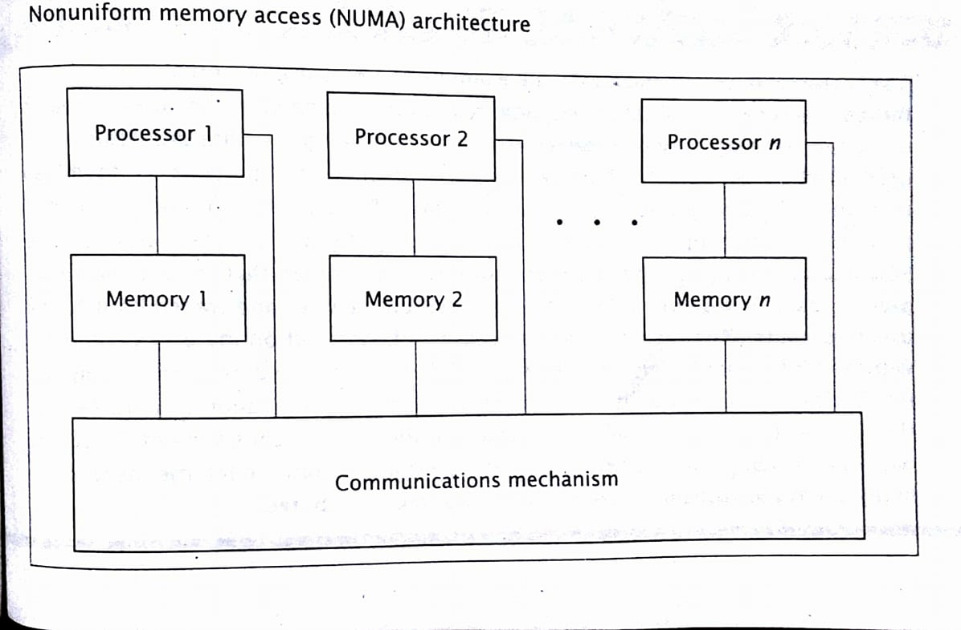

- The cache coherence NUMA architecture, CC-NUMA, is similar to the NUMA architecture , except each processor includes cache memory.
- The cache can buffer data from memory modules that are not local to the processor, thus reducing the access time of the lengthiest memory transfers.
- However, this introduces a problem when two or more caches hold the same piece of data.
- When one processor changes the value of this data, the other caches’ values are invalid.
- There are several methods to maintain consistency, or coherence.

